# The Annual Quality Assurance Report (AQAR) of the IQAC

**2017-18**



Part – A

**1. Details of the Institution**

**Lokmanya Mahavidyalaya, Warora, Dist. Chandrapur**

1.1 Name of the Institution

Abhyankar Ward, Warora

1.2 Address Line 1

Tal. Warora, Dist. Chandrapur.

Address Line 2

Warora

City/Town

Maharashtra

State

442907

Pin Code

[Lokmanya\_mahavidyalaya@rediffmail.com](mailto:Lokmanya_mahavidyalaya@rediffmail.com)

Institution e-mail address

07176 - 282053

Contact Nos.

**Dr. J. P. Shastri**

Name of the Head of the Institution:

Tel. No. with STD Code:

07176 - 282053

Mobile:

09371467593

**Prof. Shrikant N. Puri**

Name of the IQAC Co-ordinator:

09595365652

Mobile:

[lokmanya\_mahavidyalaya@rediffmail.com](mailto:lokmanya_mahavidyalaya@rediffmail.com)

[purishrikant1984@gmail.com](mailto:purishrikant1984@gmail.com)

IQAC e-mail address:

1.3 **NAAC Track ID** MHCOGN 14050

[www.lokmanyamahavidyalaya.org](http://www.lokmanyamahavidyalaya.org)

1.4 Website address:

Web-link of the AQAR:

For ex. http://www.ladykeanecollege.edu.in/AQAR201213.doc

1.5 Accreditation Details

|  |  |  |  |  |  |
| --- | --- | --- | --- | --- | --- |
| Sl. No. | Cycle | Grade | CGPA | Year of Accreditation | Validity Period |
| 1. | 1st Cycle | C | 1.86 | March 28, 2010 | March 27, 2015 |
| 2. | 2nd Cycle | B | 2.16 | March 28, 2017 | March 27, 2022 |

1.6 Date of Establishment of IQAC: DD/MM/YYYY

19/08/2011

**1.7 AQAR for the year *(for example 2010-11)***

2017-2018

1.8 Details of the previous year’s AQAR submitted to NAACafterthe latest Assessment and Accreditation by NAAC (*(for example AQAR 2010-11submitted to NAAC on 12-10-2011)*

1. AQAR 2016-17 submitted to NAAC on -------

1.9 Institutional Status

University State Central Deemed Private

Y

Affiliated College Yes No

N

Constituent College Yes No

N

Autonomous college of UGC Yes No

Yes - UGC

Regulatory Agency approved Institution Yes No

(eg. AICTE, BCI, MCI, PCI, NCI)

Y

Type of Institution Co-education Men Women

Y

Urban Rural Tribal

Y

Y

Y

Financial Status Grant-in-aid UGC 2(f) UGC 12B

N

Y

Grant-in-aid + Self Financing Totally Self-financing

1.10 Type of Faculty/Programme

Y

Arts Science Commerce Law PEI (Phys Edu)

Y

TEI (Edu) Engineering Health Science Management

    Nil

Others (Specify)

1.11 Name of the Affiliating University *(for the Colleges)*

**Gondwana University, Gadchiroli (MS)**

1.12 Special status conferred by Central/ State Government-- UGC/CSIR/DST/DBT/ICMR etc

No

Autonomy by State/Central Govt. / University

NO

University with Potential for Excellence

No

UGC-CPE

No

DST Star Scheme

No

UGC-CE

No

UGC-Special Assistance Programme

No

DST-FIST

No

UGC-Innovative PG programmes

No

UGC-COP Programmes

No

Any other (*Specify*)

**2. IQAC Composition and Activities**

7

2.1 No. of Teachers

1

2.2 No. of Administrative/Technical staff

1

2.3 No. of students

2.4 No. of Management representatives

1

1

2.5 No. of Alumni

2. 6 No. of any other stakeholder and

2

community representatives

0

2.7 No. of Employers/ Industrialists

1

2.8 No. of other External Experts

2.9 Total No. of members

14

2.10 No. of IQAC meetings held

03

07

2.11 No. of meetings with various stakeholders:

03

Faculty

Non-Teaching Staff

-

03

Students

01

Alumni

-

Others

No

2.12 Has IQAC received any funding from UGC during the year? Yes No

Nil

If yes, mention the amount

2.13Seminars and Conferences (only quality related)

(i) No. of Seminars/Conferences/ Workshops/Symposia organized by the IQAC

0

0

0

0

Total Nos. International National State

0

Institution Level

---

(ii) Themes

2.14 Significant Activities and contributions made by IQAC

* One Day Workshop on CBCS Syllabus at University level in Marathi, English, History, Political Science and Sociology was organized on 09 August 2017
* An informative lecture ‘Career in Charted Accountancy’ was arranged for the students of B. Com. and B. A. Economics
* Encouraging faculty for increased use of ICT in teaching and learning process.
* Organized Inter-collegiate University Level Music (Vocal and Instrumental) Competition.
* Blood donation camp arranged in collaboration with HDFC, Warora and Life Line Blood Bank, Nagpur
* The informative lecture by Dr. Satish Wate, former Director at CSIR-NEERI, Nagpur, was arranged in Principal L. B. Sainis Jan-Vidnyan Lecture Series on “Contribution Common People in Balancing Environment”.
* Arranged Special Residential Camp through NSS in Mandavghorad Village.
* ‘Vrukshadindi ani Vrukshaoropan’ program was organized in collaboration with Municipal Council, Warora

2.15 Plan of Action by IQAC/Outcome

The plan of action chalked out by the IQAC in the beginning of the year towards quality

enhancement and the outcome achieved by the end of the year \*

|  |  |
| --- | --- |
| Plan of Action | Achievements |
| 1. to prepare year-wise plan for each subjects  2. to prepare plan for five years  3. To add new books for the subjects according to their requirement.  4. To extend academic arena  5. To help the needy students and give incentive prizes form the Student Welfare Fund  6. To undertake research activities like MRP/ Seminars/ Workshop  7. Training Programs  8. To maintain the position at the university and inter-college sports competition (esp. Kabbadi, Yoga, Volleyball, etc )  9. To arrange cultural programme competition at the college and university level  10. Coaching for Guidance for Competitive Exams  11. To continue and arrange best practices  12. To hold tests for each semester, GD, and other types of internal evaluations.  13. To undertake Social and Extra-curricular programs in and out of the college campus  14. To arrange Jan-Vidnyan Lecture Series  15. To arrange Study tours | 1. It was decided that the annual plan will be prepared for each subject. It will be recorded at the beginning of the Diary of daily teaching report.  2. For the planning of five years, in each subject either of the departments will arrange workshop/ seminar/ send proposals for MRP. This year ‘one day university level workshop in CBCS syllabi in English/ Marathi/ Sociology/ Political Science/ History was organized.  3. The books are ordered and 459 books are delivered as per the requirement. 138 books are donated.  4. Proposals are submitted for B. Sc. Degree Course and P. G. in History and Sociology. Local Enquiry Committee of Gondwana University has submitted its report on factual observation.  5. From Student Welfare Fund, Sana Sheikh, a student of B. A. I, was helped pay college fee. Five students are given t-shirts as incentive prizes for their selection in the university teams.  6. One day university level Workshop on CBCS syllabi in English, Marathi, History, Sociology and Political Science were organized on 09th August 2017. The work of MRP of Dr. Lonkar is not started due to the lack of fund. All of the faculty members have published research papers in impact factor and UGC approved journals. Two faculties have applied for Ph. D. guide-ship.  7. Training Programs like Paytm App, Mobile and Internet Banking were organized for students of B. A. and B. Com. Placement Awareness progrom was organised. Two of the faculty have attained Ph. D. coursework. One faculty has attained Refresher Course.  8. Ms. Payal Satpute (B. A. II) participated in All India University Yoga Competition, Bhuwaneshwar. Ms. Priya Thawari (B. A. II) participated in West Zone Inter University Badminton Competition, Jalgaon University, Jalgaon. Mr. Vaibhav Bodhe (B. A. I) participated in All India Unversity Circle Kabaddi Competition at Chandigad. Ms. Achal Pimpalkar (B. A. III) and Ms. Sonu Chaukhe (B. A. I) participated in Maharashtra Level Volleyball Competition Kridamohotsav, Dapoli Kokan.  9. Intercollegiate Music Competition of GU, Gadchiroli was organized on 26 September 2017. Sanket Waghmare secured first place in the Tabala Competition. He also participated in Inter-University Cultural Fest, Indradhanush held at Parbhani. Dipak Wani secured first place in university level competition of Clay-Modelling. He also competed in Indradhanush Cultural Fest at Parbhani.  Nikita Ghume got second place in the University-level Classical Vocal Song Competition. College also achieved second place in group song. Ashish Yete got second place in “Swachhata Mitra Karndak Spardha” held at Warora Tahasil level.  The cultural programs were also arranged in the NSS camp and in the college for college students. The prizes were given according to their performance.  10. The Guidance, knowledge, mock-exams and placement awareness program were arranged by the Career Guidance Cell.  11. All the three practices ‘Granth-sanwad’, ‘Best Cheet’ (B. C.) for books, ‘Student Welfare Fund’ from teachers are regularly undertaken.  12. Tests, classroom Seminars, GD, etc are undertaken from time to time.  13. The Social and Extra-curricular programs were undertaken like tree-plantation, Blood Donation, Cyber Crime awareness, ‘Swachha Sarvekshan 2018’, Traffic Rules awareness etc in and out the campus.  14. Dr. Satish Wate, former director, NEERI, Nagpur talked on “Contribution of Common People in Maintaining Environmental Balance” in Principal L. B. Sainis Jan-Vidnyan Lecture Series”  15. Excursion to Ramtek, Khindashi, Diksha-Bhumi was organized by Environmental Studies Dept. on 05 March 2018. |

***\* Attached the Academic Calendar of the year as Annexure: I***

Yes

2.15 Whether the AQAR was placed in statutory body Yes No

Yes

Management Syndicate Any other body

Provide the details of the action taken

Approval taken for the submission of AQAR (Academic Year 2016-17) from the Local Management Council of the college

Part – B

**Criterion – I**

**1. Curricular Aspects**

1.1 Details about Academic Programmes

|  |  |  |  |  |
| --- | --- | --- | --- | --- |
| Level of the Programme | Number of existing Programmes | Number of programmes added during the year | Number of self-financing programmes | Number of value added / Career Oriented programmes |
| Ph D | 0 | 0 | 0 | 0 |
| PG | 1 | 1 | 2 | 0 |
| UG | 2 | 0 | 1 | 0 |
| PG Diploma | 0 | 0 | 0 | 0 |
| Advanced Diploma | 0 | 0 | 0 | 0 |
| Diploma | 0 | 0 | 0 | 0 |
| Certificate | 0 | 0 | 0 | 0 |
| Others | 0 | 0 | 0 | 0 |
| **Total** | 3 | 1 | 3 | 0 |

|  |  |  |  |  |
| --- | --- | --- | --- | --- |
| Interdisciplinary | 0 | 0 | 0 | 0 |
| Innovative | 0 | 0 | 0 | 0 |

1.2 (i) Flexibility of the Curriculum: **CBCS**/Core**/Elective option** / Open options: Elective Option

(ii) Pattern of programmes:

|  |  |
| --- | --- |
| Pattern | Number of programmes |
| Semester | 2 |  |  |  |
| Trimester | - |
| Annual | - |

1.3 Feedback from stakeholders\* ***(On all aspects)***

Alumni : Yes

Parents : Yes

Employers : --

Students : Yes

Mode of feedback:

Online : No

Manual : Yes

Co-operating schools (for PEI) : No

***\*Provided an analysis of the feedback in the Annexure: II***

1.4 Whether there is any revision/update of regulation or syllabi, if yes, mention their salient aspects.

CBCS pattern is introduced to PG (English and Marathi). It is also introduced to B. A. Part I and B. Com. Part I.

1.5 Any new Department/Centre introduced during the year. If yes, give details.

M. A. in Marathi is started in the college in this academic year.

**Criterion – II**

**2. Teaching, Learning and Evaluation**

|  |  |  |  |  |
| --- | --- | --- | --- | --- |
| Total | Asst. Professors | Associate Professors | Professors | Others |
| 9 | 7 | 0 | 1 | 1 |

2.1 Total No. of permanent faculty

4

2.2 No. of permanent faculty with Ph.D.

|  |  |  |  |  |  |  |  |  |  |
| --- | --- | --- | --- | --- | --- | --- | --- | --- | --- |
| Asst. Professors | | Associate Professors | | Professors | | Others | | Total | |
| R | V | R | V | R | V | R | V | R | V |
| - | - | - | - | - | - | - | - | - | - |

2.3 No. of Faculty Positions Recruited (R) and Vacant (V) during the year

2.4 No. of Guest and Visiting faculty and Temporary faculty

0

9

1

2.5 Faculty participation in conferences and symposia:

|  |  |  |  |
| --- | --- | --- | --- |
| No. of Faculty | International level | National level | State level |
| Attended Seminars/ Workshops | 4 | 0 | 6 |
| Presented papers | 0 | 0 | 0 |
| Resource Persons | 0 | 2 | 0 |

2.6 Innovative processes adopted by the institution in Teaching and Learning:

1. OHP and PPT are used to teach students as well as to evaluate them through seminars.
2. The videos and CDs on various topics in the syllabi are shown in the class.
3. Brain storming and ice-breaking methods are used sometimes.

2.7 Total No. of actual teaching days during this academic year

180 Days

2.8 Examination/ Evaluation Reforms initiated by the Institution (for example: Open Book Examination, Bar Coding, Double Valuation, Photocopy, Online Multiple Choice Questions)

Gondwana University started distributing question-papers online. Reassessment of the answer-sheet is provided to the students on their demand of it.

2.9 No. of faculty members involved in curriculum restructuring/revision/syllabus development as member of Board of Study/Faculty/Curriculum Development workshop

Dr. B. R. Pandey, the Principal, is on Board of Studies of English. He is also a member of BCUD of GU, Gadchiroli.

80%

2.10 Average percentage of attendance of students

2.11 Course/Programme wise distribution of pass percentage:

|  |  |  |  |  |  |  |
| --- | --- | --- | --- | --- | --- | --- |
| Title of the Programme | Total no. of students appeared | Results | | | | |
| Distinction | I% | II% | III% | Pass% |
| B. A. (III) | 126 | - | 15 | 31 | 64 | 87.30% |
| M. A. (II) | 08 | - | - | 3 | 1 | 50% |

2.12 How does IQAC Contribute/Monitor/Evaluate the Teaching & Learning processes:

* Conduction of induction programs, workshops and training programs
* Feedback from students
* API –PBAS is obtained from the teachers

2.13 Initiatives undertaken towards faculty development

|  |  |
| --- | --- |
| *Faculty / Staff Development Programmes* | *Number of faculty benefitted* |
| Refresher courses | 2 |
| UGC – Faculty Improvement Programme | 0 |
| HRD programmes | 0 |
| Orientation programmes | 0 |
| Faculty exchange programme | 0 |
| Staff training conducted by the university | 0 |
| Staff training conducted by other institutions | 0 |
| Summer / Winter schools, Workshops, etc. | 0 |
| Others | 0 |

2.14 Details of Administrative and Technical staff

|  |  |  |  |  |
| --- | --- | --- | --- | --- |
| Category | Number of Permanent  Employees | Number of Vacant  Positions | Number of permanent positions filled during the Year | Number of positions filled temporarily |
| Administrative Staff | 4+ (4 peons) | 0 | 0 | 0 |
| Technical Staff | 0 | 0 | 0 | 1 |

**Criterion – III**

**3. Research, Consultancy and Extension**

3.1 Initiatives of the IQAC in Sensitizing/Promoting Research Climate in the institution

* Motivated to publish research paper in various reputed journals, etc.
* Promoted faculty members to attend seminars, conferences, workshops, etc.
* Students are assigned home-assignments which creates research aptitude in them.
* Teachers are encouraged to pursue their Ph. D.

3.2Details regarding major projects

|  |  |  |  |  |
| --- | --- | --- | --- | --- |
|  | Completed | Ongoing | Sanctioned | Submitted |
| Number | 0 | 0 | 0 | 0 |
| Outlay in Rs. Lakhs | 0 | 0 | 0 | 0 |

3.3 Details regarding minor projects

|  |  |  |  |  |
| --- | --- | --- | --- | --- |
|  | Completed | Ongoing | Sanctioned | Submitted |
| Number | 0 | 0 | 1 | 0 |
| Outlay in Rs. Lakhs | 0 | 0 | 1,25,000/- | 0 |

3.4 Details on research publications

|  |  |  |  |
| --- | --- | --- | --- |
|  | International | National | Others |
| Peer Review Journals | 03 | 0 | 1 |
| Non-Peer Review Journals | 0 | 0 | 0 |
| e-Journals | 1 | 0 | 0 |
| Conference proceedings | 1 | 3 | 2 |

3.5 Details on Impact factor of publications:

Range: Nil

Average: Nil

h-index: Nil

Nos. in SCOPUS: Nil

3.6 Research funds sanctioned and received from various funding agencies, industry and other organisations

|  |  |  |  |  |
| --- | --- | --- | --- | --- |
| Nature of the Project | Duration  Year | Name of the  funding Agency | Total grant  Sanctioned | Received |
| Major projects | - | - | - | - |
| Minor Projects | 2015-17 | UGC | 1,25,000/- | 00 |
| Interdisciplinary Projects | - | - | - | - |
| Industry sponsored | - | - | - | - |
| Projects sponsored by the University/ College | - | - | - | - |
| Students research projects  *(other than compulsory by the University)* | - | - | - | - |
| Any other(Specify) | - | - | - | - |
| Total | - | - | 1,25,000/- | 00 |

1,25,000/-

3.7 No. of books published

0

i) With ISBN No.

0

Chapters in Edited Book

0

ii) Without ISBN No.

3.8 No. of University Departments receiving funds from

N

UGC-SAP

N

CAS

N

DST-FIST

N

DPE

N

DBT Scheme/funds

3.9 For colleges

N

Autonomy

N

CPE

N

DBT Star Scheme

N

INSPIRE

CE

N

-

Any Other (specify)

3.10 Revenue generated through consultancy

00

3.11 No. of conferences organized by the Institution

|  |  |  |  |  |  |
| --- | --- | --- | --- | --- | --- |
| Level | International | National | State | University | College |
| Number | 0 | 0 | 0 | 0 | 0 |
| Sponsoring agencies | 0 | 0 | 0 | 0 | 0 |

1 Person

3.12 No. of faculty served as experts, chairpersons or resource persons

One Person (Dr. B. R. Pandey)

3.13 No. of collaborations

International

0

0

National

0

Any other

3.14 No. of linkages created during this year: **Nil**

3.15 Total budget for research for current year in lakhs: **Nil**

0

From Funding agency

0

From Management of University/College

0

Total

3.16 No. of patents received this year

|  |  |  |
| --- | --- | --- |
| Type of Patent |  | Number |
| National | Applied | 0 |
| Granted | 0 |
| International | Applied | 0 |
| Granted | 0 |
| Commercialised | Applied | 0 |
| Granted | 0 |

3.17 No. of research awards/ recognitions received by faculty and research fellows

|  |  |  |  |  |  |  |
| --- | --- | --- | --- | --- | --- | --- |
| Total | International | National | State | University | Dist | College |
| 0 | 0 | 1 | 0 | 0 | 0 | 0 |

Of the institute in the year

3.18 No. of faculty from the Institution who are Ph. D. Guides and students registered under them.

Ph. D. Guides : 01

Students Registered (pursuing) under them : 03

3.19 No. of Ph.D. awarded by faculty from the Institution: Nil

3.20 No. of Research scholars receiving the Fellowships (Newly enrolled + existing ones)

0

0

JRF SRF Project Fellows Any other

0

0

3.21 No. of students Participated in NSS events:

University level : 03

State level : 02 (NSS)

National level : Nil

International level : Nil

3.22 No. of students participated in NCC events:

University level : Nil

State level : Nil

National level : Nil

International level : Nil

3.23 No. of Awards won in NSS:

University level : Nil

State level : Nil

National level : Nil

International level : Nil

3.24 No. of Awards won in NCC:

University level : Nil

State level : Nil

National level : Nil

International level : Nil

3.25 No. of Extension activities organized

University forum : Music Competition (Vocal and Musical Instrument) was organized

College forum : Nil

NCC : Nil

NSS : 01 (special residential camp was arranged at Mandawghorad village for its exclusive development)

Any other : 1. quiz, and 2. GK Exam and 3. L. B. Sainis Science Lecture series

3.26 Major Activities during the year in the sphere of extension activities and Institutional Social Responsibility

* One Day **Workshop on CBCS Syllabus at University level** in **Marathi, English, History, Political Science and Sociology** was organized on 09 August 2017
* An informative lecture ‘Career in Chartered Accountancy’ was arranged for the students of B. Com. and B. A. Economics on 09 December 2017
* Organized Inter-collegiate University Level Music (Vocal and Instrumental) Competition.
* Blood donation camp arranged in collaboration with HDFC, Warora and Life Line Blood Bank, Nagpur on December 8, 2017
* The informative lecture by Dr. Satish Wate, former Director at CSIR-NEERI, Nagpur, was arranged in Principal L. B. Sainis Jan-Vidnyan Lecture Series on “Contribution Common People in Balancing Environment” on 20 January 2018.
* Arranged Special Residential Camp through NSS in Mandavghorad Village 24 to 30 December 2017. It has undertaken various social activities and exclusive development of the village through shosh-pit, health check-up camp, animal-husbandry camp, cultural-social awareness programmes, lectures on intellectual topics, paving draining, sanitation activities, etc
* ‘Vrukshadindi ani Vrukshaoropan’ program was organized in collaboration with Municipal Council, Warora
* On the occasion of AIDS Jan Jagriti Saptah and Doctor Babasaheb Ambedkar Mahaparinirvan Diwas, a programme was organized on December 6, 2017. Dr. Pavan Darve delivered a lecture on the dangers of AIDS. Dr. B. R. Pandey spoke on the life and deeds of Dr. B. R. Ambedkar.
* Organized the lecture of Shri Ashok Koli, Police Inspector, chandrapur Police Station, on 14 December 2017 the topic “National Anthem, Traffic Rules and Cyber Crime”
* Career Guidance and Counseling Cell conducts regular coaching classes on every Saturday and Sunday. It has also organised common tests.
* In collaboration with Microline Customer Service, Warora, the Centre organized One-Day Workshop on “Net-Banking” under the central government Mission of Cashless India.
* College students and the faculty planted trees in and out of the college campus on 05 July 2017.
* 26 NSS volunteers (Police Mitra) helped The Local Police on 05 September 2018 for Ganesh Visarjan Festeval.
* Ms. Payal Satpute (B. A. II) participated in All India University Yoga Competition, Bhuwaneshwar. Ms. Priya Thawari (B. A. II) participated in West Zone Inter University Badminton Competition, Jalgaon University, Jalgaon. Mr. Vaibhav Bodhe (B. A. I) participated in All India Unversity Circle Kabaddi Competition at Chandigad. Ms. Achal Pimpalkar (B. A. III) and Ms. Sonu Chaukhe (B. A. I) participated in Maharashtra Level Volleyball Competition Kridamohotsav, Dapoli Kokan.
* Intercollegiate Music Competition of GU, Gadchiroli was organized on 26 September 2017. Sanket Waghmare secured first place in the Tabala Competition. He also participated in Inter-University Cultural Fest, Indradhanush held at Parbhani. Dipak Wani secured first place in university level competition of Clay-Modelling. He also competed in Indradhanush Cultural Fest at Parbhani.
* Nikita Ghume got second place in the University-level Classical Vocal Song Competition. College also achieved second place in group song. Ashish Yete got second place in “Swachhata Mitra Karndak Spardha” held at Warora Tahasil level.

**4. Infrastructure and Learning Resources**

4.1 Details of increase in infrastructure facilities:

|  |  |  |  |  |
| --- | --- | --- | --- | --- |
| Facilities | Existing | Newly created | Source of Fund | Total |
| Campus area | 2.42 Acres | 0 | - | 2.42 |
| Class rooms | 05 | 0 | - | 05 |
| Laboratories | 03 | 0 | - | 03 |
| Seminar Halls | 0 | 0 | 0 | 0 |
| No. of important equipment purchased (≥ 1-0 lakh) during the current year. | 0 | 0 | 0 | 0 |
| Value of the equipment purchased during the year (Rs. in Lakhs) | 0 | 0 | 0 | 0 |
| Others(Gymnasium, and Indoor Stadium) | 01 | 0 | - | 01 |

4.2 Computerization of administration and library

Yes: software 2 (LIB-MAN for library and College Management Service Software for office)

4.3 Library services:

|  |  |  |  |  |  |  |
| --- | --- | --- | --- | --- | --- | --- |
|  | Existing | | Newly added | | Total | |
| No. | Value | No. | Value | No. | Value |
| Text Books | 1,763 | 3,14,932/- | 261 | 62,054/- | 2,024 | 3,76,986/- |
| Reference Books | 5,908 | 15,62,372/- | 376 | 88,160/- | 6,284 | 16,50,532/- |
| e-Books | - | - | - | - | - | - |
| Journals | 4763 | - | 437 | 16,983/- | 5,200 | - |
| e-Journals | - | - | - | - | - | - |
| Digital Database | - | - | - | - | - | - |
| CD & Video | 111 | - | 2 | 00 | 113 | - |
| Others (specify)Maps | 16 | - | 4 | 700 | 20 | - |

4.4 Technology up gradation (overall)

|  |  |  |  |  |  |  |  |  |
| --- | --- | --- | --- | --- | --- | --- | --- | --- |
|  | Total Computers | Computer Labs | Internet | Browsing Centres | Computer Centres | Office | Departments | Others |
| Existing | 37 Comps.  3 Laptops | 1 Comp. Lab,  1 Lang. Lab. | 05 BSNL Broad band | 22 Comps. Lab. | 01 | 8 Comps. + 3 Laptops | - | 1 Stadium |
| Added | 0 | 0 | 0 | 0 | 0 | 0 | - | 0 |
| Total | 40 | 02 | 05 | 22 | 01 | 11 | - | 1 |

4.5 Computer, Internet access, training to teachers and students and any other programme for technology up-gradation (Networking, e-Governance etc.)

* In the college, there are 36 computers with internet connectivity for the teaching and the non-teaching staff, and the students.
* Teachers are given training of Interactive Whiteboard.
* Three-day workshop was arranged for students on “Computer Literacy / Applications of ICT”

4.6 Amount spent on maintenance in lakhs:

0.30

i) ICT

3.22

ii) Campus Infrastructure and facilities

0.00

iii) Equipments

00

iv) Others

3.52Lakhs

**Total :**

**Criterion – V**

**5. Student Support and Progression**

5.1 Contribution of IQAC in enhancing awareness about Student Support Services

* Displaying of Notices regarding various Scholarships and Free-ships.
* Running of Centre for Competitive Examination.
* Motivated the girl students to participate in various sports.
* Interaction of Librarian with the students.
* Use of UGC-NRC Internet facifility

5.2 Efforts made by the institution for tracking the progression

* Formally, feedback forms are obtained from the stakeholders.
* Use of informal methods like personal communications, emails, social network sites, Alumni association meetings.

|  |  |  |  |
| --- | --- | --- | --- |
| UG | PG | Ph. D. | Others |
| 719 | 108 | - | - |

5.3 (a) Total Number of students

(b) No. of students outside the state

0

(c) No. of international students

0

|  |  |
| --- | --- |
| No | % |
| 150 | 18.13 |

|  |  |
| --- | --- |
| No | % |
| 677 | 81.87 |

Men Women

|  |  |  |  |  |  |  |  |  |  |  |  |
| --- | --- | --- | --- | --- | --- | --- | --- | --- | --- | --- | --- |
| Last Year | | | | | | This Year | | | | | |
| General | SC | ST | OBC | Physically Challenged | Total | General | SC | ST | OBC | Physically Challenged | Total |
| 24 | 60 | 88 | 448 | 3 | 677 | 30 | 67 | 109 | 552 | 4 | 827 |

Demand ratio: 1:0.86 (940:824) Dropout: 22% (UG); 32% (PG)

5.4 Details of student support mechanism for coaching for competitive examinations (If any)

Yes. Career and Guidance cell sponsored by UGC gives special training by the renowned teachers.

150

No. of students beneficiaries

5.5 No. of students qualified in these examinations

0

1

0

0

NET SET/SLET GATE CAT

IAS/IPS etc State PSC UPSC Others

8

0

1

0

5.6 Details of student counselling and career guidance

1. Career and Guidance cell yearly runs competitive classes and guidance for students.
2. Once a year a common test is held for the college students in Warora.
3. A quiz is held, in which toppers in the test are competitors.

No. of students benefitted

120

5.7 Details of campus placement

|  |  |  |  |
| --- | --- | --- | --- |
| ***On campus*** | | | ***Off Campus*** |
| Number of Organizations Visited | Number of Students Participated | Number of Students Placed | Number of Students Placed |
| 0 | 0 | 0 | 25 |

* 1. Details of gender sensitization programmes
* One-day sensitisation workshop on “Breastfeeding and Nutrition” by Dr. Kishor Bhattacharya, Medical Officar, Kosalsar Civil Hospital on International Milk-Feeding Day was organised on 07 August 2015.
* Essay competition on “Importance of Breastfeeding” was arranged by Mahila Adhyayan Study Department and Home-Economics Department.

5.9 Students Activities

5.9.1 No. of students participated in Sports, Games and other events

State/ University level: 02 (NSS)

National level : 09 (Sports)

International level : 00

No. of students participated in cultural events

State/ University level : 09

National level : 02

International level : 00

5.9.2 No. of medals /awards won by students in Sports, Games and other events

Sports:

State/ University level : 00

National level : 00

International level : 00

Cultural:

State/ University level : 03

National level : 00

International level : 00

5.10 Scholarships and Financial Support

|  |  |  |
| --- | --- | --- |
|  | Number of  students | Amount |
| Financial support from institution | - | - |
| Financial support from government | 664 | 39,07,486/- |
| Financial support from other sources | - | - |
| Number of students who received International/ National recognitions | - | - |

5.11 Student organised / initiatives

Fairs :

State/ University level : 00

National level : 00

International level : 00

Exhibition:

State/ University level : 00

National level : 00

International level : 00

**NSS camp and College Cultural Program**

5.12 No. of social initiatives undertaken by the students

5.13 Major grievances of students (if any) redressed: **Rates of food items of Canteen are asked to keep reasonable. The quality and quantity of food are improved.**

**Criterion – VI**

**6. Governance, Leadership and Management**

6.1 State the Vision and Mission of the institution

**Vision:**

Lok Shikshan Sanstha, the parent body which patronizes the college, has its own ways and vision. It does not believe in linear growth of a child. Multiple and globular development of personality with attitude towards cultural nationalism makes a child perfect as a civilian or a professional, it believes. The Sanstha toils hard with this view close to its chest.

Lokmanya Mahavidyalaya, Warora has specific objective to provide higher education to the adolescents coming from the tribal areas and the mofussil. It prefers to work as a facilitator of curriculum-based education to the young enthusiasts.

**Mission:**

1. To provide the facility of higher education to the students coming from inaccessibly remote, rural and backward areas.
2. To train the youngsters in such a way that they may grow as responsible citizens
3. To expose the students to healthy attitude, rational and scientific in tone and texture.
4. To infuse a sense of belonging to the society with graceful, dignified, and confident outlook.
5. To make the youth understand the problems that the denizens face in the rural and unreachable areas.
6. To make the teaching-learning process healthy, enjoyable, and soaked with human sensibility.

6.2 Does the Institution has a management Information System

Nil

6.3 Quality improvement strategies adopted by the institution for each of the following:

6.3.1 Curriculum Development

The institution maintains a record of the feedback received from stakeholders related with the teaching-learning process and tries to implement that.

6.3.2 Teaching and Learning

The college has a system of evaluating the knowledge and skill learnt by the students. Unit Tests and two terminal examinations decide about the slow and quick learners.

* Slow learners are specifically guided through tutorials and by conducting extra-classes.
* The advanced learners are counselled to peep into the reference books and other materials pertaining to general knowledge and current affairs.

6.3.3 Examination and Evaluation

There is the College Examination Committee in the college. It is responsible for framing specific programme for four Unit Tests and two terminal examinations. The results are declared as soon as possible. Feedback over the performance of the students is also given to them.

6.3.4 Research and Development

The faculty members attended seminars, conferences and workshops related with research and development. They are also motivated to publish research papers, articles, etc. in reputed journals. They give such assignments to students that develop research-aptitude among students.

6.3.5 Library, ICT and physical infrastructure / instrumentation

1. Library Committee, after interaction with students and teachers, suggests books to purchase. The students can borrow books on their B. T. Card, Id. Card, etc. the library is kept open during college time.
2. ICT and infrastructure is used and purchased according to the necessity. The Language laboratory, O. H. P., P. P. T., videos and CDs related to syllabi are also shown. Internet connectivity is also available.
3. The modern GIM is available for the students’ health.

6.3.6 Human Resource Management

* Recruitment of faculty on vacant teaching posts on non-granted (aided) branches.

6.3.7 Faculty and Staff recruitment

Nil

6.3.8 Industry Interaction / Collaboration

Not Applicable, since the college has only Arts Stream.

6.3.9 Admission of Students

On the basis of marks obtained in the qualifying examination the merit list of the students is prepared and displayed prominently. Dates for interview are fixed as per merit. At the time of interview the students are given proper counselling. After verification of the necessary documents, admission committee finalizes the admission.

|  |  |
| --- | --- |
| Teaching | Book Best Chit (B. C.); training to handle Interactive Whiteboard |
| Non teaching | Book Best Chit (B. C.); |
| Students | Students Welfare Fund; ICT workshop for students; workshop on importance of breastfeeding |

6.4 Welfare schemes for

12,000/- Rs. yearly

6.5 Total corpus fund generated

yes

6.6 Whether annual financial audit has been done Yes No

6.7 Whether Academic and Administrative Audit (AAA) has been done?

|  |  |  |  |  |
| --- | --- | --- | --- | --- |
| Audit Type | External | | Internal | |
| Yes/No | Agency | Yes/No | Authority |
| Academic | - | - | Yes | C. A. |
| Administrative | - | -- | - | - |

6.8 Does the University/ Autonomous College declares results within 30 days?

No

For UG Programmes Yes No

Yes

For PG Programmes Yes No

6.9 What efforts are made by the University/ Autonomous College for Examination Reforms?

Nil

6.10 What efforts are made by the University to promote autonomy in the affiliated/constituent colleges?

Nil

6.11 Activities and support from the Alumni Association

* Informal alumni-teacher meetings are conducted.
* Formally, alumni-teacher meet is arranged once a year.

6.12 Activities and support from the Parent – Teacher Association

* Informal Parent-teacher meetings are conducted.
* Formally, Parent-teacher meet is arranged once a year.

6.13 Development programmes for support staff

1. Granth Sanwad’
2. Book B. C.
3. L. B. Sanis Jan-Vidnyan Lecture Series
4. Arranging Warora level common general knowledge test and Quiz programme.

6.14 Initiatives taken by the institution to make the campus eco-friendly

1. Plantation
2. Solar-power
3. Water harvesting

**Criterion – VII**

**7. Innovations and Best Practices**

7.1 Innovations introduced during this academic year which have created a positive impact on the functioning of the institution. Give details.

* Faculty induction program for newly recruited teachers
* Economically backward students are given help

7.2 Provide the Action Taken Report (ATR) based on the plan of action decided upon at the beginning of the year

|  |  |
| --- | --- |
| Plan of Action | Achievements |
| 1. to prepare year-wise plan for each subjects  2. to prepare plan for five years  3. To add new books for the subjects according to their requirement.  4. To extend academic arena  5. To help the needy students and give incentive prizes form the Student Welfare Fund  6. To undertake research activities like MRP/ Seminars/ Workshop  7. Training Programs  8. To maintain the position at the university and inter-college sports competition (esp. Kabbadi, Yoga, Volleyball, etc )  9. To arrange cultural programme competition at the college and university level  10. Coaching for Guidance for Competitive Exams  11. To continue and arrange best practices  12. To hold tests for each semester, GD, and other types of internal evaluations.  13. To undertake Social and Extra-curricular programs in and out of the college campus  14. To arrange Jan-Vidnyan Lecture Series  15. To arrange Study tours | 1. It was decided that the annual plan will be prepared for each subject. It will be recorded at the beginning of the Diary of daily teaching report.  2. For the planning of five years, in each subject either of the departments will arrange workshop/ seminar/ send proposals for MRP. This year ‘one day university level workshop in CBCS syllabi in English/ Marathi/ Sociology/ Political Science/ History was organized.  3. The books are ordered and 459 books are delivered as per the requirement. 138 books are donated.  4. Proposals are submitted for B. Sc. Degree Course and P. G. in History and Sociology. Local Enquiry Committee of Gondwana University has submitted its report on factual observation.  5. From Student Welfare Fund, Sana Sheikh, a student of B. A. I, was helped pay college fee. Five students are given t-shirts as incentive prizes for their selection in the university teams.  6. One day university level Workshop on CBCS syllabi in English, Marathi, History, Sociology and Political Science were organized on 09th August 2017. The work of MRP of Dr. Lonkar is not started due to the lack of fund. All of the faculty members have published research papers in impact factor and UGC approved journals. Two faculties have applied for Ph. D. guide-ship.  7. Training Programs like Paytm App, Mobile and Internet Banking were organized for students of B. A. and B. Com. Placement Awareness progrom was organised. Two of the faculty have attained Ph. D. coursework. One faculty has attained Refresher Course.  8. Ms. Payal Satpute (B. A. II) participated in All India University Yoga Competition, Bhuwaneshwar. Ms. Priya Thawari (B. A. II) participated in West Zone Inter University Badminton Competition, Jalgaon University, Jalgaon. Mr. Vaibhav Bodhe (B. A. I) participated in All India Unversity Circle Kabaddi Competition at Chandigad. Ms. Achal Pimpalkar (B. A. III) and Ms. Sonu Chaukhe (B. A. I) participated in Maharashtra Level Volleyball Competition Kridamohotsav, Dapoli Kokan.  9. Intercollegiate Music Competition of GU, Gadchiroli was organized on 26 September 2017. Sanket Waghmare secured first place in the Tabala Competition. He also participated in Inter-University Cultural Fest, Indradhanush held at Parbhani. Dipak Wani secured first place in university level competition of Clay-Modelling. He also competed in Indradhanush Cultural Fest at Parbhani.  Nikita Ghume got second place in the University-level Classical Vocal Song Competition. College also achieved second place in group song. Ashish Yete got second place in “Swachhata Mitra Karndak Spardha” held at Warora Tahasil level.  The cultural programs were also arranged in the NSS camp and in the college for college students. The prizes were given according to their performance.  10. The Guidance, knowledge, mock-exams and placement awareness program were arranged by the Career Guidance Cell.  11. All the three practices ‘Granth-sanwad’, ‘Best Cheet’ (B. C.) for books, ‘Student Welfare Fund’ from teachers are regularly undertaken.  12. Tests, classroom Seminars, GD, etc are undertaken from time to time.  13. The Social and Extra-curricular programs were undertaken like tree-plantation, Blood Donation, Cyber Crime awareness, ‘Swachha Sarvekshan 2018’, Traffic Rules awareness etc in and out the campus.  14. Dr. Satish Wate, former director, NEERI, Nagpur talked on “Contribution of Common People in Maintaining Environmental Balance” in Principal L. B. Sainis Jan-Vidnyan Lecture Series”  15. Excursion to Ramtek, Khindashi, Diksha-Bhumi was organized by Environmental Studies Dept. on 05 March 2018. |

7.3 Give two Best Practices of the institution

1. Principal L. B. Sainis Smurti Prityarth Jan-Vidnyan Lecture Series: The informative lecture by Dr. Satish Wate, former Director at CSIR-NEERI, Nagpur, was arranged in Principal L. B. Sainis Jan-Vidnyan Lecture Series on “Contribution Common People in Balancing Environment”.
2. Collection of students’ welfare fund from the college staff. Students are given college-uniforms, sports-uniform to the economically backward students.
3. ‘Granth Sanwad’ on each Thursday.

***\*Provided the annexure III***

7.4 Contribution to environmental awareness / protection

1. Environmental Tour (Dikshabhumi, Ramtek, Pench Project in Nagpur District) was undertaken
2. Plantation in the campus and outside the campus
3. Solar-power generation system
4. Lectures, video clips, projects, etc. are undertaken by the Environment Department to make awareness about the conservation of the environment.

√

7.5 Whether environmental audit was conducted? Yes No

7.6 Any other relevant information the institution wishes to add. (for example SWOT Analysis)

**Strengths:**

* Students from rural and tribal areas
* Most of the students are girls
* Qualified staff
* Well-equipped library, UGC-NRC computer-lab. With Internet connectivity
* Experienced principal
* Supportive management and LMC
* Availability and abundant use of ICT tools
* Availability of Sports facility

**Weaknesses:**

* Lack of awareness of education among Students
* Most of the students are girls, so drop-out rate is also more

**Opportunity:**

* PG in all the Subjects can be started

**Threats:**

* Difficult to train and teach rural and tribal students
* Difficult for students to find out employment, since the college has only Arts Stream of knowledge.

8. **Plans of institution for next year**

1. to arrange national and state level seminars and workshop

2. To send proposals of Minor Research Project and Seminars to WRO, UGC, Pune

3. Plant trees in the open space of the campus and in the Tumgaon village.

4. To enlarge the building of library

5. To purchase (re-order) the text and reference books

6. To complete the construction of library building

7. To provide economically backward students with books, shoes, clothes, etc

8. To maintain the position at the university and inter-college sports competition (esp. Kabbadi, Volleyball, etc )

9. To arrange cultural programme competition in the college

10. To arrange the Common Screening Test for the students in Warora, coaching classes for competitive exams and Quiz competition under Career Guidance Cell

11. To continue and arrange practices such as ‘Granth-sanwad’, ‘Best Chit’ (B. C.) for books, ‘Student Welfare Fund’ from teachers and “Granth-sanwad”

12. To organise the blood donation camp.

 IMG_20160804_141342 (2)

*Prof. S. N. Puri Dr. B. R. Pandey*

*Signature of the Coordinator, IQAC Signature of the Chairperson, IQAC*

*\_\_\_\_\_\_\_\*\*\*\_\_\_\_\_\_\_*

Annexure – I: Academic Calendar

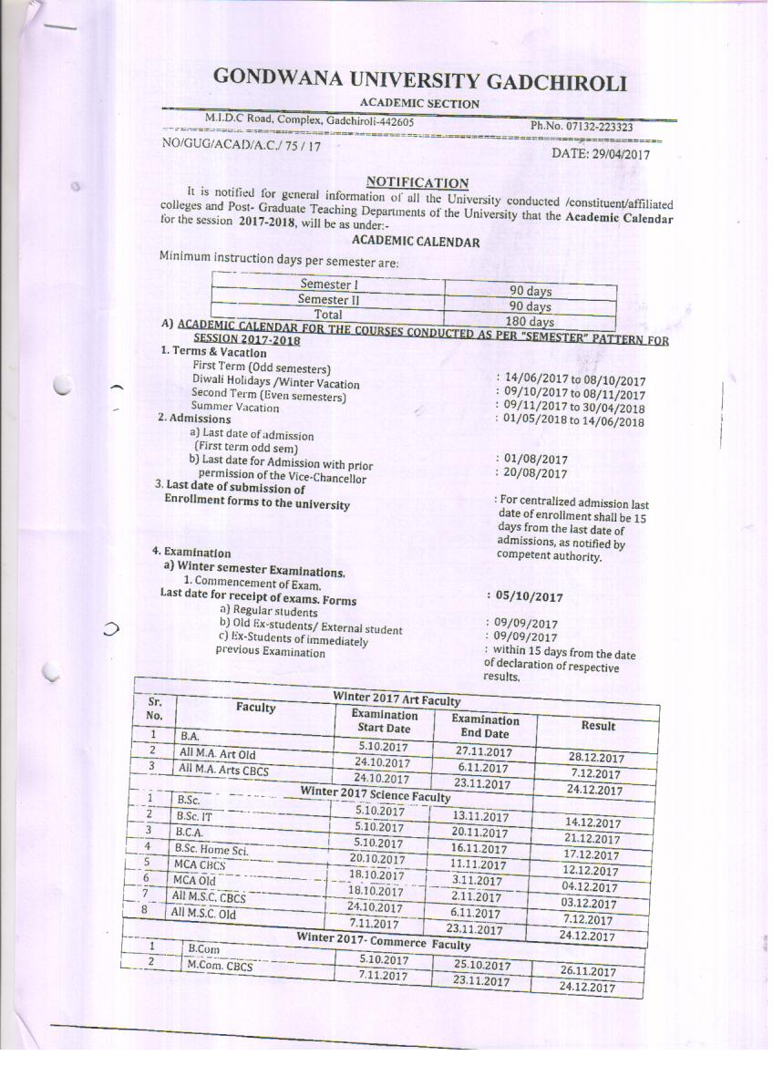

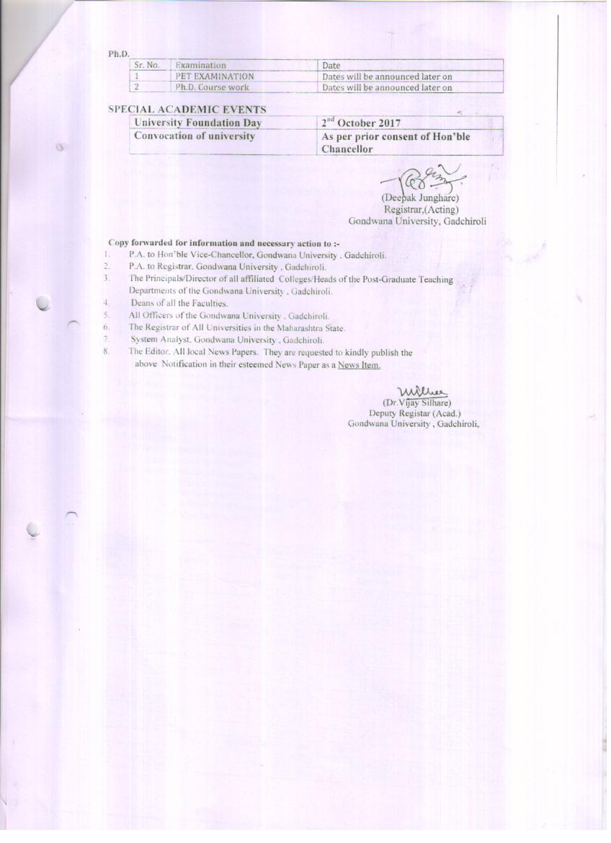

Annexure – 2: Evaluation of Students’ Feedback Forms

Part I: Institutional Evaluation

1 = Class Room; 2 = Recreational Facility; 3 = Sports Facility; 4 = Library Facility; 5 = Interaction with Administration; 6 = Laboratory and Internet; 7 = Extra-curricular Activities; 8= Over-all Rating of the Institute

**Part II: Curriculum Evaluation**

1 = Learning Value; 2 = Clarity and Relevance of Textual material; 3 = Syllabus Content; 4 = Job Prospective; 5 = Social Relevance; 6 = Skill Development; 7 = Research Applicability

**Part III: Evaluation of Teachers**

**Department of Marathi**

**Department of Sociology**

**Department of Political Science**

**Department of History**

**Department of Physical Education**

**Department of Economics**

**Department of English**

1 = Time Management; 2 = Subject Command; 3 = Confidence, Confidence and Communication Skills; 4 = Use of Teaching Aids; 5 = Internal Evaluation; 6 = Laboratory Interaction; 7 = Class Control; 8 = Guidance; 9 = Conduct

Annexure – 3: Best Practices

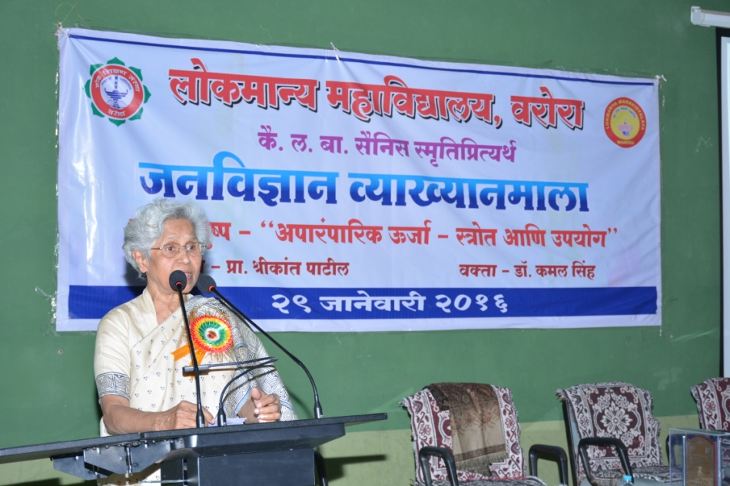

Dr. Kamal Singh dealing with

“Renewable Energy Sources and Its Application”

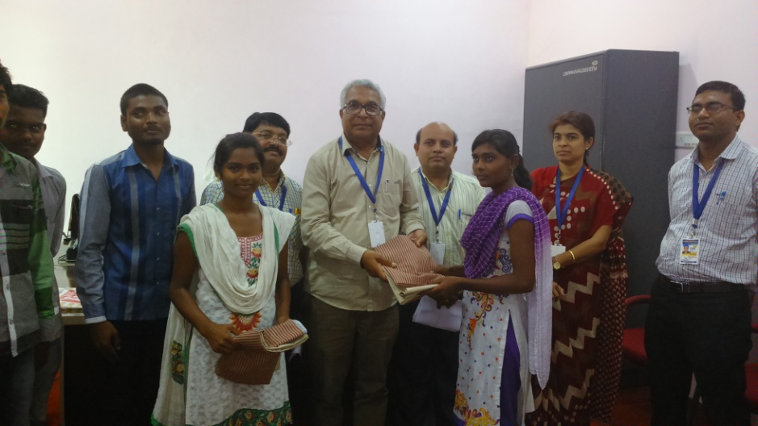

Dr. B. R. Pandey, the Principal with other Professors while giving college uniforms from the fund collected for students’ mentoring to the students

Quiz Competition

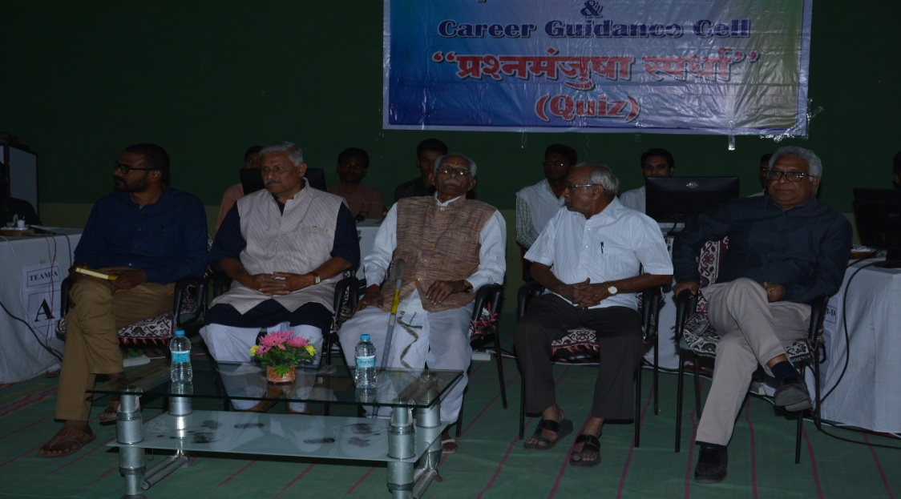

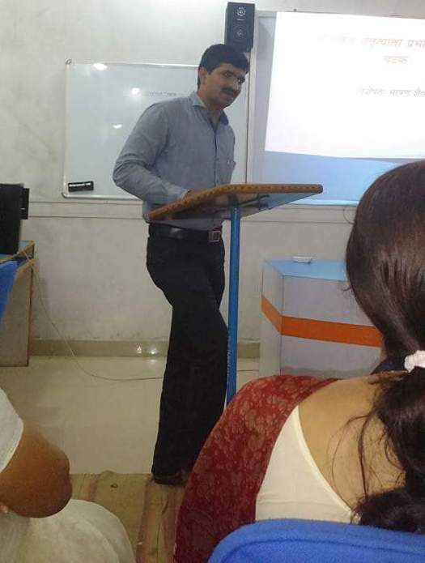

Prof. Mane, Head of department of Political Science, delivering lecture on “Oratory Skills of Different of Politicians” in Granthsanwad